LQT型金属弹簧隔振器(冷却塔专用)
LQT metal spring vibration obsorber(for cooling tower)
Page8

LQT型金属弹簧隔振器是由钢板焊接与金属弹簧组合而成，具有低频性和高稳定性，分两组弹簧、四组弹簧和八组弹簧。适用于大型的空调机组，尤其适用于冷却塔。
LQT metal spring vibration absorber(for cooling tower)is composed of Jointing steel plate and metal springs，has low frequency and high stability，can be divided into two group of springs and four group of springs It can be applied to 1arge--scale air--conditioning engine，especially to cooling tower.
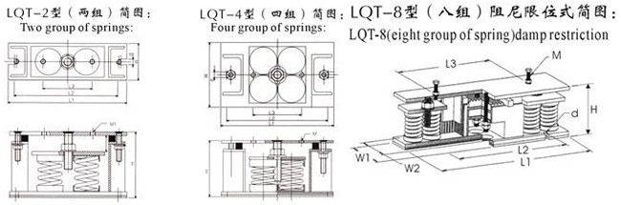
LQT一2型技术特性表：
Technological characteristic table：
型号 Type | 最大承载（kg） maxximum load | 变形（mm） Distortion | H | W | L1 | L2 | L3 | d | M1
LQT-2-300 | 300 | 28 | 165 | 95 | 300 | 265 | 120 | 14 | M12
LQT-2-450 | 450 | 28 | 165 | 95 | 300 | 265 | 120 | 14 | M12
LQT-2-600 | 600 | 28 | 165 | 95 | 300 | 265 | 120 | 14 | M12
LQT-2-800 | 800 | 28 | 165 | 95 | 300 | 265 | 120 | 14 | M12
LQT-2-1000 | 1000 | 28 | 190 | 95 | 300 | 265 | 120 | 18 | M16
LQT-2-1200 | 1200 | 28 | 190 | 95 | 300 | 265 | 120 | 18 | M16
LQT-2-1500 | 1500 | 28 | 190 | 95 | 300 | 265 | 120 | 18 | M16
LQT-2-1800 | 1800 | 28 | 190 | 95 | 300 | 265 | 120 | 18 | M16
LQT-2-2000 | 2000 | 28 | 190 | 95 | 300 | 265 | 120 | 18 | M16
LQT一4型技术特性表：
Technological characteristictable：
型号 Type | 最大承载（kg） maxximum load | 变形（mm） Distortion | H | W | L1 | L2 | L3 | d | M1
LQT-4-400 | 400 | 28 | 140 | 160 | 280 | 250 | 120 | 14 | M12
LQT-4-600 | 600 | 28 | 160 | 160 | 280 | 250 | 120 | 14 | M12
LQT-4-800 | 800 | 28 | 160 | 160 | 280 | 250 | 120 | 14 | M12
LQT-4-1200 | 1200 | 28 | 160 | 160 | 280 | 250 | 120 | 14 | M12
LQT-4-2000 | 2000 | 28 | 200 | 200 | 300 | 265 | 120 | 18 | M16
LQT-4-3000 | 3000 | 28 | 200 | 200 | 300 | 265 | 120 | 18 | M16
LQT-4-4000 | 4000 | 28 | 200 | 200 | 300 | 265 | 120 | 22 | M16
LQT-4-6000 | 6000 | 28 | 200 | 200 | 300 | 265 | 120 | 22 | M16
LQT一8型技术特性表：
Technological characteristictable：
型号 Type | 最大承载（kg） maxximum load | 变形（mm） Distortion | H | W1 | W2 | L1 | L2 | L3 | M | d
LQT-8-800 | 800 | 25 | 186 | 180 | 150 | 590 | 420 | 380 | M16 | ￠14
LQT-8-1600 | 1600 | 25 | 186 | 180 | 150 | 590 | 420 | 380 | M16 | ￠14
LQT-8-4000 | 4000 | 25 | 234 | 220 | 180 | 670 | 460 | 380 | M20 | ￠22
LQT-8-8000 | 8000 | 25 | 234 | 220 | 180 | 670 | 460 | 380 | M20 | ￠22
LQT-8-13500 | 13500 | 25 | 262 | 350 | 280 | 890 | 660 | 450 | M24 | ￠25
LQT-8-18000 | 18000 | 25 | 262 | 350 | 280 | 890 | 660 | 450 | M24 | ￠25
注：本厂还定制生产挠度(变形量)1时、2时、3时、4时，即25mm、50mm、75mm、100mm及以上产品。
Note：We also custom products，the deflection(defolmation) of which is 1，2，3，4 inches，namely 25，50，75，100 mm or above.

