ZTD型阻尼弹簧大载荷隔振器

ZTD high load damp spring vibration absorber

Page4
ZTD型阻尼弹簧大载荷隔振器，全系列共有十二种规格，单只隔振器的垂向载荷自1～16吨可任意选择，各种载荷下对应的自振频率均在4.8Hz以下，可基本满足大中型设备的消极隔振和积极隔振，也可用作隔声房等单体房隔振。产品采用侧向阻尼限位，提高刚度和阻尼保证房屋、设备正常使用。
There are 12 specifications in this series．Vertical load of each vibration absorber can be chosen from 1 to 16 tons，intrinsic Vibration frequency is less than 4.8HZ under difierent load．These products Can be applied to positively Vibr~ion absorption and passively vibration absorption for large and medium sized equipment，they also are useful to insulate Vibr~ion for separated cell like isolation booth．They can ensurethe natural run o buildings and equipments by side damp restriction to improve rigidity and damp．
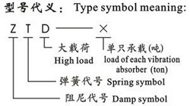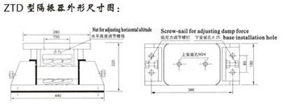
ZTD型阻尼弹簧大载荷隔振器技术参数表：
Technological parameter table of ZTD high load damp spring vibration absorber：
型号 Type | 最佳荷载（T） optimal load(T) | 荷载范围（T） scope of load(T) | 频率范围（Hz） frequency scope(Hz) | 垂直刚度N/mm vertical rigidity N/mm | 阻尼比范围 damp ratio scope
ZTD-1 | 1 | 0.5-1.5 | 4.8-2.8 | 480 | 0.06-0.2
ZTD-2 | 2 | 1月3日 | 4.8-2.8 | 960 | 0.06-0.2
ZTD-3 | 3 | 2月4日 | 4.8-2.8 | 1920 | 0.06-0.2
ZTD-4 | 4 | 2.7-5.3 | 4.7-3.4 | 2400 | 0.06-0.2
ZTD-5 | 5 | 3.5-6.7 | 4.5-3.3 | 2880 | 0.06-0.2
ZTD-6 | 6 | 4月8日 | 4.8-3.5 | 3840 | 0.06-0.2
ZTD-7 | 7 | 4.6-9.5 | 4.8-3.4 | 4320 | 0.06-0.2
ZTD-8 | 8 | 5.3-10.7 | 4.8-3.3 | 4800 | 0.06-0.2
ZTD-9 | 9 | 6月12日 | 4.8-3.5 | 5760 | 0.06-0.2
ZTD-10 | 10 | 6.7-13 | 4.8-3.5 | 6240 | 0.06-0.2
ZTD-12 | 12 | 8月16日 | 4.8-3.5 | 7488 | 0.06-0.2
ZTD-16 | 16 | 10.7-21.3 | 4.8-3.5 | 9984 | 0.06-0.2

ZTI型阻尼弹簧大荷载隔振器采用金属弹簧与阻尼器并列使用，阻尼比为0.10～0.25，全系列共有五种规格，单只垂向荷载自2500~62000牛顿，可任意选择，对应各频率在3.1～5Hz以下，可满足大中型设备的消极和积极隔振。
This product is composed of metal spring mad damper，damp ratio is 0.10～0.25．There're 5 specification in this series．Vertical load of each vibration absorber can be chosen from 2500N～62000N．intrinsic vibration frequency is less than 3．1～5HZ。This product can be applied to positively and passively vibration absorption for large and medium sized equit)ment ．
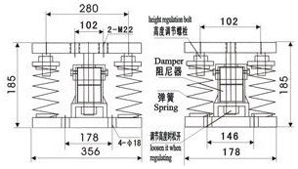
型号 Type | 最佳荷载 （T） optimal load(T) | 荷载范围 （T） scope of load(T) | 频率范围 （Hz） frequency scope(Hz) | 垂直刚度N/mm vertical rigidity N/mm
ZTI-250 | 2500 | 1680-4200 | 3.1-5 | 168
ZTI-680 | 6800 | 4560-11400 | 3.1-5 | 456
ZTI-1600 | 16000 | 10500-26250 | 3.1-5 | 1050
ZTI-3250 | 32500 | 21680-54200 | 3.1-5 | 2168
ZTI-6200 | 62000 | 41400-103500 | 3.1-5 | 4140

